Multicast Forwarding
Scope Effort

Revision 0.2
Hui Shao
Date Last Updated May. 9, 04

Revision History
Date | Version | Description | Author
2004-4-12 | 0.1 | Initial draft | Hui Shao
2004-5-9 | 0.2 | Updated based on email discussions | Hui Shao

Table of Contents
Revision History 1
1 Objective 3
1.1 Goals 3
1.2 Non-goals 4
1.3 Deliverable 4
2 Scope 4
2.1 Scope Decomposition 4
2.1.1 Aggregator service 4
2.1.2 Test Utilities 5
2.1.3 Documents 6
2.1.4 Training 6
2.2 Architecture Considerations 6
2.2.1 Reliability 6
2.2.2 Scalability 6
2.2.3 Compatibility 6
2.3 Dependencies 6
2.4 Resources 7
2.4.1 Software 7
2.4.2 Hardware 7
2.4.3 Human resource 7
2.5 Milestones 7
3 Issues and Pending Decisions 7
3.1 The layer 4 that the Aggregator operates 7
3.2 Convert connectionless-oriented traffic to connection-oriented traffic 8
3.3 Loop and Duplicate Traffic Avoidance 8
3.3.1 Rules applied to the resender interface 8
3.3.2 Rules applied to the listener interface 8
3.4 IPv4 and IPv6 Mixing 8
3.5 Master/Slave Processing 8
3.6 Default configuration values 9
4 References 9

Objective
It is anticipated that there are environments where ITV and other applications, would like to use or need to use multicast, but may not be allowed in portions of the customer network.
For example, it maybe acceptable from the customer perspective, for an application to use multicast in a subnet, but the multicast will never be allowed past the router serving the subnet. However, the application software may need to have a multicast conversation that spans 2 or more subnets.

Goals
Build a service or daemon that will
- aggregate multicast traffic,
- forward it via a connection-oriented protocol to a receiving service or daemon
- re-multicast the traffic at the receiving service or daemon
- be able to be configured between 2 or more subnets
It is the rough equivalent of a V-LAN for multicast support.

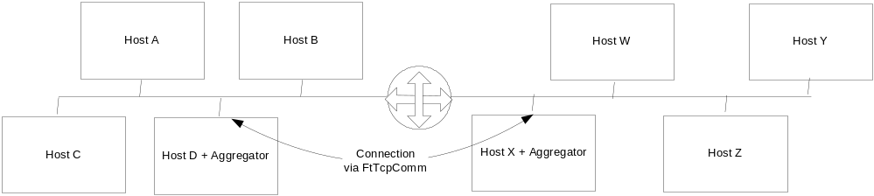
Figure 1, Small 2 Network System

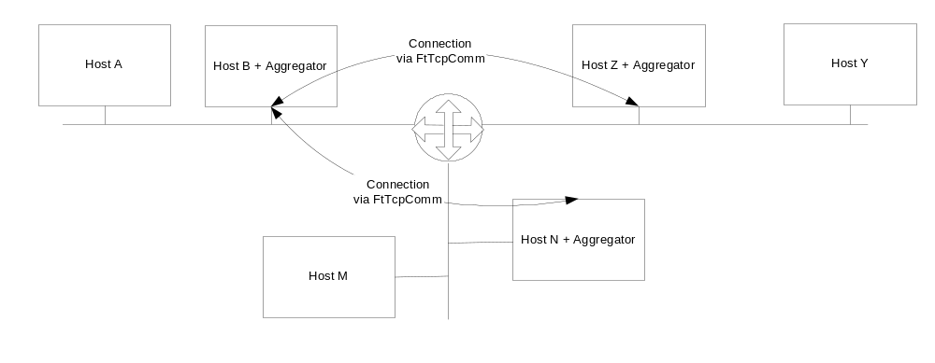
Figure 2, Medium 3 Network System
In the small 2 network system above, a collection of nodes in both networks may want to participate in 1 single multicast conversation. The aggregators in each network would be configured to listen for that conversation and forward it to the other side.
In the above 3-network system, a multicast conversation is required to traverse all three network segments. In this case the Aggregator on Hosts B, N and Z would be required to forward multicast messages on their local subnet to the other aggregators and the destined aggregator would subsequently re-multicast the received messages on their local subnet.

Non-goals
Non-Windows implementation will not be included in this release;
Windows NT 4.0 support is optional.

Deliverable
The following pieces will be delivered as part of this development effort:
- The aggregator service or daemon (including source code and project build settings)
- Test utilities
- Documents (including a user manual of aggregator)
- Training

Scope

Scope Decomposition
This section gives details on each component. It breaks each component into subsections. The overview describes a component and the requirement for this component.

Aggregator service
Is the primary deliverable of this project. It has tree major interfaces: Multicast Listener, TCP tunnel, Multicast Resender. Also it must support SeaChange’s ManUtil, SNMP features and should address cross-platform distribution

Multicast Listener
The aggregator listen multicast packages at layer 4(OSI) through this interface. The interface must be able to
- receive UDP multicast packages on its local subnet
- handle IPv4 and IPv6 version mixing
- must filter out the package resent by its own multicast resender (2.1.3)

TCP Tunnel
One connection between any two servers must be made:
- The connection must be fault resilient by invoking MtTcpComm
- All multicast conversations between two aggregators should tunnel through a single TCP connection instead create separate TCP connections for different multicast messages/conversations
- Handle IPv4 and IPv6 version mixing
- Has a mechanism to responds the performance bottle-neck when the connectionless-oriented traffic is converted to the connection-oriented traffic

Multicast Resender
The destined aggregator would subsequently re-multicast the received messages on its local subnet through this interface:
- Resend the multicast UDP package
- Has a mechanism to work with the multicast listener (2.1.1) to prevent dead loop traffic
- Handle IPv4 and IPv6 version mixing

SeaChange Service
The aggregator must be distributed as an NT service (for Windows) or daemon (for Unix-like):
- The service distribution must use the SeaChange Service Shell and App Shell
- be configurable through the ITV configuator service
- support ManUtil and SNMP for remote management and service status

Test Utilities
The project should also provide simple utilities for testing the setup and configuration of the aggregator service. For example, the utility should have the ability to specify a conversation for a sender and receiver across one or more subnets and demonstrate the conversation is occurring with simple well-known messages.

The following test tools must be included minimally. They may be combined into a single implementation:

Mcastsend
A utility to send multicast messages by using given mc group, port and message body

Mcastrcv
A utility to receive forwarded multicast messages. It can record the traffic in a log file for reviewing

Documents
The project should provide the following documents:
- A user manual on the aggregator service and its test utilities
- Development plan (owned by ZQ, reviewed by Maynard team)
- Design documents (owned by ZQ, reviewed by Maynard team)
- Test plan (owned by ZQ, reviewed by Maynard team)

Training
Training should be provided by ZQ when the project is delivered to Maynard.
TODO: add details about the training

Architecture Considerations

Reliability
As a service, the aggregator inherits all the reliability from a standard SeaChange VOD service. It has fault resilient connection between any two servers by invoking MtTCPComm APIs. Its listener and resender interface can natively handle network failure since they are working on connectionless-oriented protocol

Scalability
The service is intended for low volume control and announcement messages but for streaming or propagation of files.

Compatibility
As a standard SeaChange service, the new service will has interfaces to ManUtil, alarm, pager and other standard SeaChange utilities. Besides them, the new service will not require additional ITV components to work, in other words, it has minimal dependents to run.
The new service can work on the existing ITV deployment without requiring additional hardware.

Dependencies
- A training on SeaChange’s svcshell, appshell, MtTcpComm and ManUtil/SNMP support), (from Maynard team)
- A detail description on master/slave processing
- IPv6 tunnel implementation is dependent on IPv6-enabled MtTcpComm

Resources

Software
MS Windows 2003
MS Visual studio.net 2003
MS IPV6 Tech Preview (for Win2000)
MS Office XP
IPv6 DNS
InstallShield 7.0

Hardware
Two or more testing subnets
Dual-NIC development machines

Human resource
Omitted

Milestones
Events | Date | Owner | Review | Notes
Loop avoidance cons | 4/30/04 | ZQ / Maynard | 4/30/04 | Dup msg goes to configuration
Basic prototype | 5/17/04 | ZQ
Other scope issues | ? | ZQ / Maynard | ? | Manutil, master/slave, etc.
Product Design Spec | ? | ZQ |  | Depends on scope issues
Implementation |  | ZQ
SQA |  | ZQ
Delivery |  | ZQ / Maynard

Issues and Pending Decisions

The layer 4 that the Aggregator operates
Both the listener and the re-sender interfaces should work on the layer 4 (OSI), no raw socket is required in this implementation.

Convert connectionless-oriented traffic to connection-oriented traffic
When the traffic is forwarded from the multicast listener to the tunnel, a traffic bottle-neck problem will be raised since the traffic bandwidth on a connection-oriented protocol is less than that on a connectionless-oriented protocol under same network condition.
The aggregator is intended for low volume control and announcement messages but for streaming or propagation. This issue is ignored here

Loop and Duplicate Traffic Avoidance
When a destined aggregator re-multicast a message through its resender interface (2.1.3), the message may be caught by its own listener (2.1.1) all other aggregator on same subnet, it could be forwarded to the source aggregator again and cause a loop traffic.
The loop traffic will be avoided by applying additional rules to the resender and the listener interfaces:

Rules applied to the resender interface
When the resender interface is going to re-multicast a message forward thru the tunnel, it will:
- Send the message thru one specified IP/port of the machine it runs on. The IP and port are configurable
- Keep the destination IP/port of the outgoing package as same as that when it was received by the source aggregator
- Set the TTL of the outgoing package to 1 to prevent it from going through any routers

Rules applied to the listener interface
The listener interface must separate those re-multicasted messages from others. The aggregator should not forward such messages to any other aggregators thru tunnels. The identification is used here will be base-on the specified port number mentioned in 3.3.1-1, or a denied-list which is configurable.

The duplicate traffic avoidance is left as a configuration problem. The administrator has to be responsible for this problem.

IPv4 and IPv6 Mixing
The listener and resender interface will work on both IPv4 and IPv6 in this release. IPv6 support on the tunnel is dependent on an IPv6-enabled MtTCPComm API

Master/Slave Processing
//TODO: (greg) add a detail description here

Default configuration values
- Formal service name, executable filename
- Reserved port number (see 3.3.1)
- XML-formated configuration scheme

References
- Multicast Forwarding Requirements by Mike Kiskiel, Gregory Holbrow, ver 0.3
- Loop & Duplicate Traffic Avoidance by Andy Shao
- Unix Network Programming Volum1 Networking APIs: Sockets and XTI(second edition) by W. Richard Stevens
- Network Programming for Microsoft Windows by Anthony Jones
- ms-help://MS.MSDNQTR.2003FEB.2052/winsock/winsock/multicast_programming.htm
- ms-help://MS.MSDNQTR.2003FEB.2052/winsock/winsock/tcp_ip_raw_sockets_2.htm
- ms-help://MS.MSDNQTR.2003FEB.2052/winsock/winsock/ipv6_guide_for_windows_sockets_applications_2.htm

Additional one day is required to prepare a detail document
the design specification doc can be expected one week later after the SeaChange service standard issues and master/slave process are addressed

